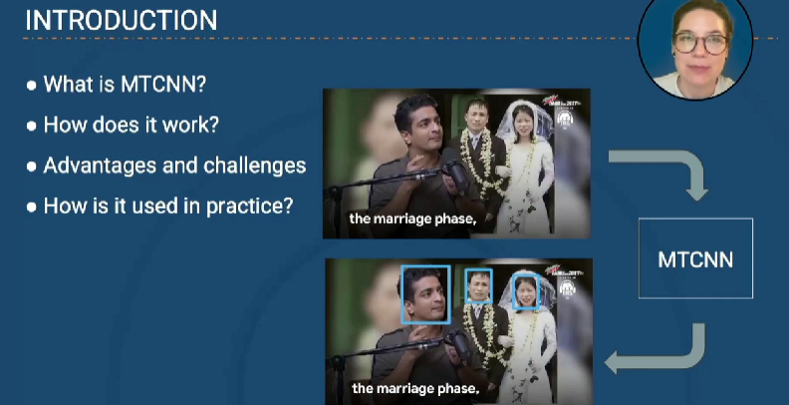

MTCNN gives three output as it can do multi task. Following are the three various output from a MTCNN.

MTCNN is a combination of three neural network that are

1. P-net – returns 3 things, it gives probability of faces and bounding boxes, this output goes to another network
2. R – net – gives refined candidate faces.
3. O- net – gives the mark of eyes, nose and all probabilities.

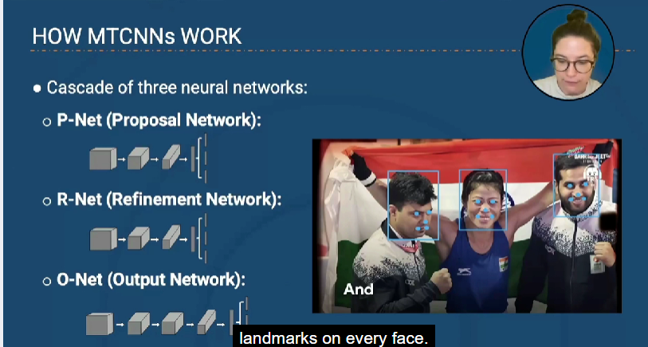

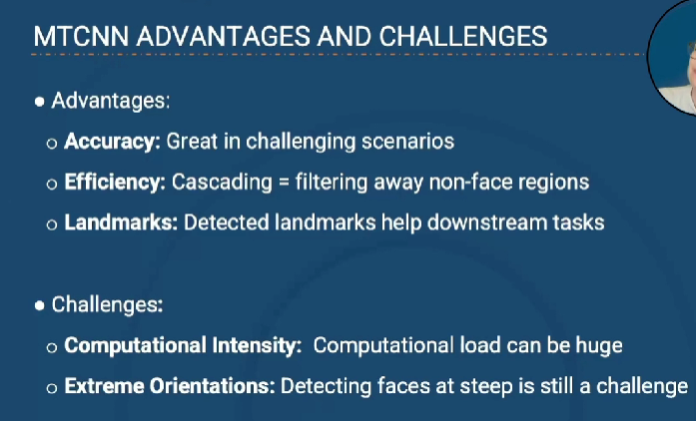

**PRE – TRAINED MODEL FOR FACE DETECTION**

